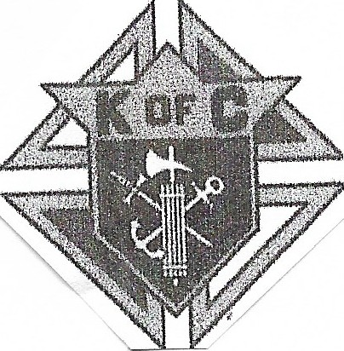
2021 Knights of Columbus State Golf Tournament Entry Form

July 17th & 18th

Council Number------
Council Name
Council Address City
Phone#
Golf Coordinator-------
E-Mail
Address City
Phone#

We will be playing a twoman scramble and your team will be pair up with a team from another council.
Prizes for Saturday tournament will be given out at the Banquet Saturday night. Sunday prizes will be given out at the golf course.

Player Name (Please list by twosome | 18 Hole | Add Extra | Total Paid
who you want to play with, then you | Avg | Banquet
will be paired up a two some from | Score | $15.00
another Council.
1.
2.
3. _

4.

Registration Fee $130.00 per Golfer includes: Green Fees, Banquet, Hot Dog at the turn, Gift items and a lot of fun.
Make checks payable to Knights of Columbus Council 1010, 333 Main Street Brookville IN. 47012. Please (note) send in by June 12 ^{th} 2021.

For Info Call Carroll Lanning@ 513-305-7996 (E-Mail clanning1970@gmail.com) Please have a Membership card with you. You must be at least a 1st degree member to play and have F.S. to sign the entry form here _

